Development of a Malaysian Plate Number Recognition System for Parking Violation
Mohd Fauzi Aliasª*, Fahmi Fitri Abdul Rahimª, Mohamad Rosyidi Ahmadª, Mohamed Yusof Radzakª, Mohd Suyerdi Omarª, Muhamad Husaini Abu Bakar^{b}

ª Department of Electric Electronic & Automation Section, Universiti Kuala Lumpur Malaysian Spanish Institute, Kulim Hi Tech Park, 09000 Kulim, Kedah, Malaysia

^{b} Department of Manufacturing Section, Universiti Kuala Lumpur Malaysian Spanish Institute, Kulim Hi-Tech Park, 09000 Kulim, Kedah, Malaysia
*With the help of SEELab

*Mohd Fauzi Bin Alias
e-mail: fauzialias@unikl.edu.my

Muhammad Fahmi Fitri bin Abdul Rahim
e-mail: fahmifitripa@gmail.com

Mohamad Rosyidi bin Ahmad
e-mail: mrosyidi@unikl.edu.my

Mohamed Yusof bin Radzak
e-mail: myusofr@unikl.edu.my

Mohd Suyerdi bin Omar
e-mail: msuyerdi@msi.unikl.edu.my

Muhamad Husaini Abu Bakar
e-mail: muhamadhusaini@unikl.edu.my

Abstract Malaysian plate number recognition (MPNR) systems have a wide range of uses, including traffic law enforcement and parking system administration. The MPNR system is non-intrusive and only requires plate number of a vehicle without any additional identification needed. The goal of this work is to create MPNR software that can be used offline. With an average rate of more than 80, the software should be able to recognize the location and read the number plate. The proposed MPNR algorithm was created to respond to the Malaysian traffic conditions. Several pre- and post-processing techniques, including plate’s location, character extraction, segmentation, and recognition were used in the creation of the MPNR algorithm. The developed MPNR algorithm was put through its paces in order to assess its performance and capabilities. According to the findings, the system is dependable and strong, and its capacity to distinguish a number plate for a parking infringement indicates that it has a lot of promise for traffic and transportation research.

Keywords - MPNR, localization, extraction, character segmentation and recognition, parking violation

1. Introduction
A car plate recognition system helps people efficiently read car plate numbers, saving time and energy. Before the computer-based car identification, the number of the car plate was recorded manually with the use of a pen and paper until the great photo-enforcement technology was introduced after the cold war. In 1993, it successfully moved from the research centre to the business market. More recently, a growing number of suppliers from all over the world have been finding their way to more solutions-oriented systems.

The technology of the imaging processing is a technique used for the treatment of the image as a two-dimensional signal and for standard signals. This technique is a critical technique to read the car plate number from the car picture in the car plate recognition system. There are many ways in which different suppliers design a car plate recognition system such as an automatic number plate recognition, automatic identification of vehicles, car plate detection, auto plate reader, or optical plate numbers and characters recognition of vehicles is also known as automation plate recognition technology. Car plate recognition has various applications since the vehicle license plate is the most important, widely accepted and legible person, obligatory motor vehicle identification. This system has been used by many to identify stolen cars throughout the world based on an up to date blacklist. Other useful applications include the control of vehicle access, automatic collection of charges, real-time monitoring and security, and management of the parking area.

2. Literature Review
  - Automatic Plate Number Recognition
Vehicle licence plate recognition (LPR) has been used in a variety of applications, including entrance admittance, parking control, traffic control, security, and speed control, according to the project's article. They are, however, ineffective when the vehicle image is presented in a variety of formats and styles. Furthermore, much of this software assumes that the camera's position and distance from autos are limited [9]. In recent years, automatic plate number recognition (APNR) has proven to be a useful technique for vehicle monitoring. The APNR has three steps namely number plate localization (NPL), character segmentation, and optical character recognition (OCR). Vehicle licence plate recognition (LPR) has been used in a variety of applications, including entrance admittance, parking control, traffic control, security, and speed control, according to the project's article. They are, however, ineffective when the vehicle image is presented in a variety of styles and formats. In addition, most of these software assumes some limits on the camera's position and distance from cars [9]. Typically, an APNR system consists of three main stages namely number plate localization (NPL), character segmentation and optical character recognition (OCR). The number plate is detected at the NPL stage. In the OCR stage, characters are segmented and recognized from the plate number [16]. Based on some research that has been made, there are three main stages in the most common methods used in order to complete the APNR system.

  - Existing Methodology for Automatic Plate Number Recognition
Based on the APNR research, computer vision and license plate recognition, character algorithms are important in video image numerical picture analysis. The key modules in an APNR system are therefore formed. The automatic car licence plate recognition system includes a camera, a computer, , frame reception and a custom software for the analysis of the image and video processing. There are four stages in an APNR system that extracts a licence plate number from a specific image [1]. Camera parameters such as size and resolution has to be considered. The plate is then removed from the image in the next stage depending on several parameters such as the colour’s boundary or the presence of letters. In the third stage, the segmentation process is applied to the licence plate. The characters and numbers are extracted using their color data, label, or model matching. Finally, the retrieved characters must be recognised by matching templates or decision makers such as neural networks and fuzzy techniques. An APNR system's performance is based on the robustness of each stage.

    - Plate Number Extraction
The plate number extraction stage has an impact on the accuracy of any system. This stage takes a car image as input and outputs an area of the potential plate number. The plate numbers and characters can be seen in the whole image. Instead of analysing each pixel in the image, which would take longer, the system can distinguish the plate based on its attributes, and only those pixels with these characteristics are processed. The characteristics are determined by the licence plate's format and characters.

All possible rectangles in the image can be recovered because the licence plate has a rectangular shape with a specified aspect ratio. Edge detection algorithms are widely utilised for these rectangles. [1],[4]-[7]. For the detection of edges, a sobel filter is used in [1],[5],[8]-[11]. The boundary of the plate can bee seen by the transition of intensity between the plate and the body of car. During edge detection process, the edges can be seen as two different lines representing different intensity of colors. In [3], the rectangle plate is detected by the geometric parameters used to locate rectangular lines. Some research applied the matching edges to locate the regions [1],[5],[8],[12]. A robust extraction feature is the magnitude of the edges on the plate [6]. In [1], some candidate rectangles are matched to the vertical edges. Applicants are considered rectangles with the same ratio as the license plate. Based on different conditions, this method yielded a result of 96.2% on images. According to [5], the plate area can be easily extracted from the edge image if the vertical edges are removed and the background edges are removed. In 1165 images, the detection rate was around 100%. The total processing time of one picture was 47.9ms.

    - Plate Number Segmentation
Then the separate plate is segmented to remove the identification characters. In a pre-processing, the segmentation algorithms should overcome tilt and non uniform problems. The bi-linear transformation is used in [14] and [16] to map a straight rectangle of the tilted extracted license plate. In [17], in the license plate images, a minimum square approach is used to handle horizontal tilt and vertical tilt. In [18] the character coordinates are arranged in a two-dimensional covariance matrix according to the Karhunen-Loeve transform. The correction of the horizontal tilt picture is completed by calculating the eigenvector and the α rotation angle. For vertical tilt correction, line fitting based on the clustering of K-means and minimal squares been applied purposely to measure the tilt angle. In [19], a line fitting method was introduced based on the least square fitting with perpendicular offsets to correct a horizontal tilt of the license plate.

Some of the characters are difficult to segment especially when an inappropriate threshold is selected to binarize the two separated characters in the combined process. Some characters may be attached to the frame after binarization, making it difficult to segment with a surrounding frame [20]. Improving image quality prior to binarization allows picking the correct threshold [20]. Several techniques commonly applied to enhance the image are the noise removal, histograms equalization, and contrast. In [20], a system was proposed to conduct gradient analysis over the entire image to detect the license plate and then grey level transformation enhances the license plate detected. A strategy was suggested in [21] to improve only the characters and reduce the noise.

The character’s size is estimated to be about 20% of the size of the license plate. The grey-scale rate is normalized to 0-100, so 2.55 is multiplied by a maximum of 20 million pixels. Although noise pixels are minimized, only characters are improved. For each pixel, regional thresholding is used in [22]. The threshold value is measured by subtracting a constant c in an mxn window mask centred at the pixel from the mean grey point. In [23], the Niblack binarization equation provides the basis for changing the limit over the picture based on the local mean (m) and standard deviation (σ).

Prior character knowledge can help the license plate segmentation. In [10], a horizontal line scans the binary image to find the character start and end positions. If, the value lower than this threshold, the character’s pixels to background’ pixel ratio exceed the selected threshold and can be considered as the starting position of the characters. In [2], the plate extracted is resized to a selected size of the template. In the research, the position of the characters are known. The same locations are removed after resizing to be the characters. This method has a simplicity advantage. Nevertheless, the abstraction occurs in history rather than characters in the case of any change in the removed license plate.

    - Plate Number Recognition
As the ouput, the characters and numbers are extracted and recognized. The extracted numbers and characters produce different size and thickness due to the zoom factor of a camera [13],[20]. In order to solve the problem, numbers and characters are resized before the recognition process. Extracted and resized characters may be noisy or broken [13]. It is also possible to tilt the extracted characters [13]. Template matching in recognition [1] is one of the option and straightforward method. A character's similarity to the templates is measured. The template is known as the goal which is the closest to the character. Many template matching approaches use binary images instead of greyscale image. This is due to less intensity values because of the changes of lighting [17]. Several research has implemented the template matching techniques after the extracted character has been resized to the template’s size[1],[8],[13],[14],[20]. In the literature, several similarity measurement techniques are defined.

Recognition of characters in [20] uses standard cross correlation in the matching technique. To measure the normalized cross-correlation, the template scans each numbers and characters by column and result the highest similarity between them. The normalized output value of each matching process falls between 0-1. Template matching is also useful to recognize a single font characters, unbroken, and fixed size. If owing to any font shift, rotation or noise a character is different from the template, the template matching generates inaccurate recognition [17]. In [15], recognizing tilted characters can be solved by storing multiple similar character templates with different angles of tilt.

3. Methodology
The purpose of this project is to focus on a MATLAB simulation of the MPNR system image processing method. The images captured should be straightforward to process and should not have any flaws in the number plate, such as missing characters.. In Malaysia, there are two types of car plates, black and white plates. White plates uses black characters. This type of plate is used by commercial car such as taxi and limosin. The other plate is white characters in a black plate. This type of plate are used by the passenger car. The block diagram of the method used is shown in Fig. 1.

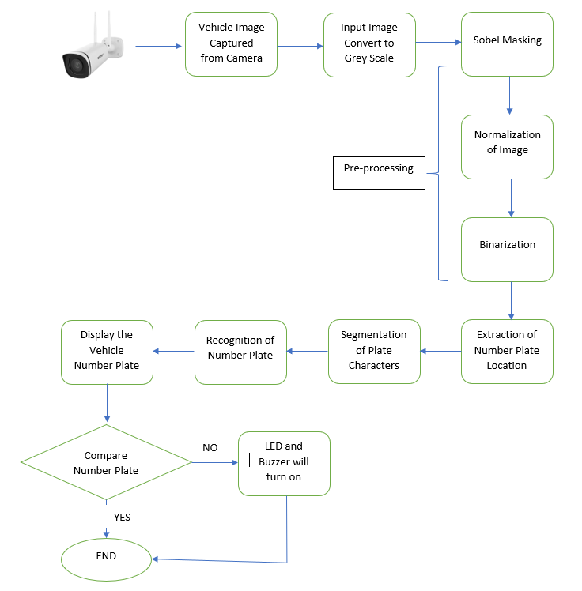
Pre-Processing
Figure 1. Flow chart of algorithm

3.1 Vehicle Image Captured by Camera
The process of getting an image from a camera is known as image acquisition. The MPNR system's first component is this. The acquisition device sends a static image to the MPNR system for number plate recognition. There are essentially two methods for acquiring an image by using:
• digital or mobile camera
• an analogue or IP (surveillance) camera
A digital camera or a mobile camera was used to take the images for the MPNR system.
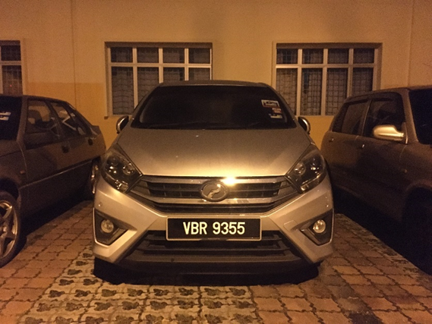

Figure 2. Input image from Camera

  - Extraction of Number Plate Location
Detecting the plate size is the basic step in recognizing the vehicle number plate. There are generally number plates in a rectangular shape, therefore the edges of the rectangular plate must be detected. For obtaining the edge of a rectangular plate, plotting the edge histogram makes it easier to choose the plate region. Based on the edge horizontal histogram, use the threshold value of the edge horizontal histogram to find the candidate's plate rows and mask the number plate region using the Mask function in MATLAB. This method is used for subtracting all other regions and only focuses on the region of interest. It helps to break down the vehicle's number plate area. Finally, we can find the biggest area of the binary region as late location by computing the area of every region and only select the biggest binary region using the command in MATLAB. After that, crop the plate location using the imcrop command.

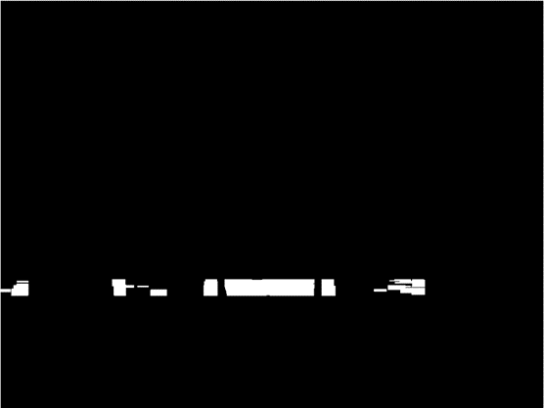
a
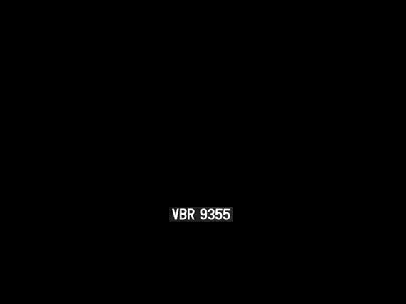
b


c

Figure 3. (a) Masked plate (b) plate location (c) number plate extracted

  - Segmentation of Number Plate
Segmentation is one of the most critical processes in the recognition of the number plate. A character may be mis-divided into two or more characters if segmentation fails. The ultimate solution to this problem is to use the connected component technique. So, after cutting the licence plate, use im2bw to binarize the image. This is the process of converting grey values in an image to binary values and re-presenting the image as a binary image. Binarization of photographs emphasises essential pixels while suppressing those in the background. The simplest technique to choose an image binarization threshold value is to classify all pixels with values over the threshold as white (255 grey value) and all other pixels as black (0 grey value). The command used in MATLAB is im2bw (“number plate cropped”,0.4). For the second time, use the eroding operation to smooth the edge of characters. After that, we remove all objects containing fewer than 100 pixels.

Then, proceed using the connected component method. The bounding box is used to determine the image region's properties. Once a bounding box has been created over each character and numbers shown on the number plate, each character and number are separated for number plate recognition.


Figure 4. Bounding box created

  - Recognition of Plate Characters
In this stage, after segmenting each character from the vehicle’s number plate as shown in the Fig. 4, we are going to use that segmented character for the translation of text images to characters. Number plate recognition is now used by using template matching to compare each individual character to the entire alphanumeric database. The matching process moves the template image in a larger source image to all possible positions and calculates a numerical index indicating how well the template matches the image in that position. Pixel-by-pixel matching is done. The template size is 42 × 24. Since the template size is fixed, it leads to accurate recognition.
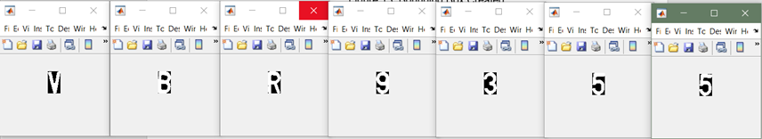

Figure 5. Each character segmented

  - Display Vehicle Number Plate and Alert System
Finally, the recognised number plate of the car is shown in notepad. Figure 14 shows the notepad containing the number plate that has been recognized after notepad has printed the recognized plate number. The comparison between the reserve car’s number plate and current recognized car’s number plate has been done by using a compare string array for the equality command in MATLAB. When the current car’s number plate not equal to the reserve number plate, output has been sent to Arduino Uno to activate a LED and Piezo buzzer, alerting someone in charge to act on parking violation. The fig. 6 shows the hardware setup of an alert system for the parking violation.
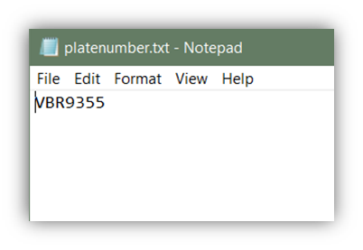
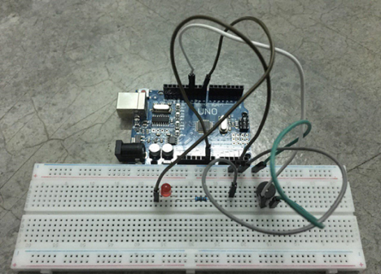
Figure 6. (a) Number plate shown in notepad (b) hardware setup for parking violation
b
a

4. Results and Discussions

The MPNR tests were conducted to determine the ability of the MPNR code to detect the number plate position and to read the numbers. The MPNR code has been tested on a laptop with the following configurations: HP Pavilion 2.71GHz, 8.00 GB RAM. A total of 50 plates images were used to test the MPNR code in MATLAB R2019a. Table 1 shows the result of the test that has been conducted. The result has been categorized into 3 groups namely as input images, image pixels and processing time.

Table 1. Processing time of input images

Input Images | Image Pixels | Processing Time(s)
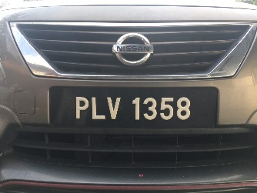 | 960 x 1280 | 16.6186
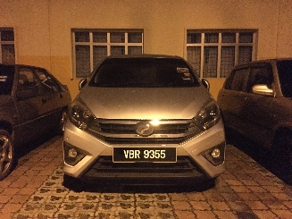 | 3024 x 4032 | 24.8701
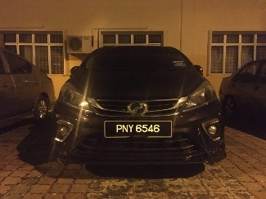 | 960 x 1280 | 17.2546
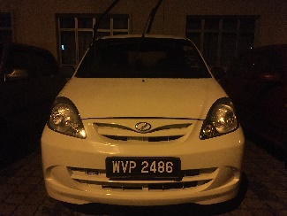 | 3024 x 4032 | 33.6011
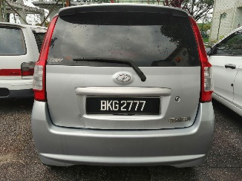 | 960 x 1280 | 17.8871
Table 1 shows the execution time of the MATLAB software in seconds. The input images are being processed through all the step of the methodology, starting from the pre-processing the image until the number plate been printed in notepad. The table 1 shows that the processing time becomes longer when higher pixels input images are being processed.

Table 2, Figs. 7 and 8 show the accuracy and the process of number plate’s position extraction respectively.
There is a certain number of failures in extracting the plate region as shown in Fig. 8. This will lead to incorrect recognition in the last stage of MPNR. From table 2, the MPNR system has 90% success rate when performing the number plate extraction on the car.

Table 2. Number plate’s position extraction

Total samples | 50
Successful number plate’s position extracted | 45
Unsuccessful number plate’s position extracted | 5
Accuracy of number plate’s position extracted (%) | 90

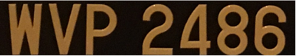
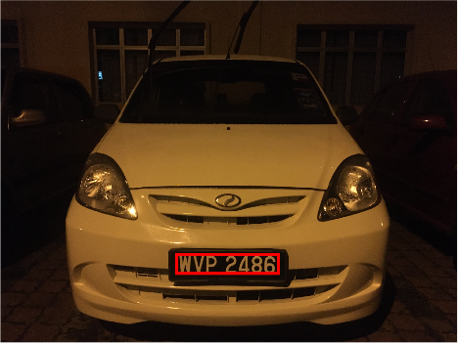

Figure 7. Number plate correctly extracted

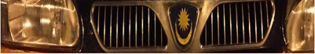
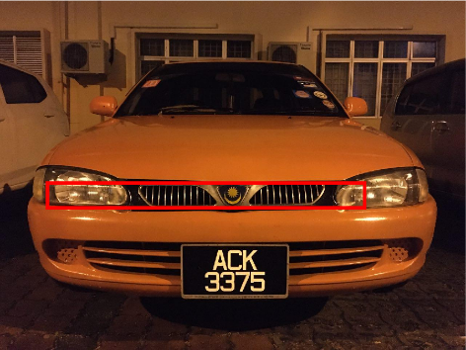
Figure 8. Number plate incorrectly extracted
Table 3, Figs. 9 and 10 show the accuracy and the process of the number plate segmentation respectively. Figs. 9 and 10 show the sample of the segmentation process of a single character from the number plate area. The segmentation process accuracy determines the smoothness of the recognition process. Fig. 10 shows that the MPNR system is unable to distinguish the body of the car from the plate number, esulting in segment the body of the car is treated as one of the characters. From the Table 3, the MPNR system has 70% of success rate when performing the number plate segmentation.

Table 3. Data collected for number plate segmentation

Total samples | 50
Successful number plate segmented | 35
Unsuccessful number plate segmented | 15
Accuracy of number plate segmented (%) | 70


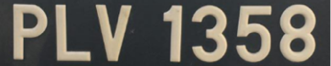

Figure 9. Number plate correctly segmented


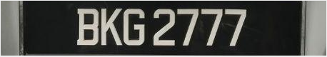

Figure10. Number plate incorrectly segmented

Table 4, Figs. 11 and 12 show the recognition accuracy and the process of number plate recognition respectively. Figs. 11 and 12 show the sample of the recognition process using MPNR and all the data has been transferred to the data center using the notepad application. Fig. 12 shows the unsuccessful segmentation process will result to the unsuccessful recognition. The recognition process has been successfully done using the correlation method. The 35 samples from the segmented number plate has been selected for the recognition process. Successful segmenting the number plate will make the recognition phase much easier. The accuracy of recognition is 94.29% as shown in Table 4.

Table 4. Data collected for number plate recognition

Total samples | 35
Successfully number plate recognized | 33
unsuccessfully number plate recognized | 2
Accuracy of number plate recognized (%) | 94.29

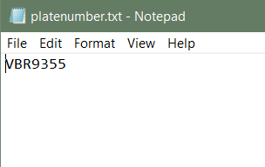


Figure 11. Correct recognition result

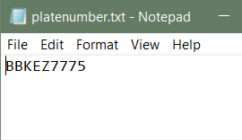


Figure 12. Incorrect recognition result

5. Conclusions
As conclusion, the project has selected the perfect methods for the plate number recognition process. The Malaysian plate number recognition (MPNR) system has managed to produce high accuracy of plate number recognition detection as high as 94.29%. One of the main contribution to the high percentage was the application of pre-processing methods such as image enhancement and segmentation. The pre-processing methods have been used to minimize the effect of lighting and make the license plate visible in order to deal with the illumination issue. The project has also set some quality comparison rules, such as the process to identify proper license plate extraction, the effective segmentation, and the recognition level of characters. By using the pre-processing methods, the character recognition becomes easier to be successfully detected as all characters on a plate are identified correctly. New sensor systems that are resilient to changing illumination conditions should also be used to improve MPNR performance. For optical character recognition, future research should focus on improving recognition rates for ambiguous characters such as (B-8), (O-0), (I-1), (A-4), (C-G), (D-O), and (K-X) as well as broken characters. To compare the performance of different MPNR systems, a standardised evaluation technique is required.

References

- M Sarfraz et al, Saudi Arabian license plate recognition system, Int Conf Geom Model and Graphics, 36-41, 2003.
- I Paliy et al, Approach to recognition of license plate numbers using neural networks, IEEE Int Joint Conf Neur Netw, 4 : 2965-2970, 2004.
- C Nelson et al, An efficient geometric feature based license plate localization and recognition, Int J Imag Syst Tech, 2 (2) : 189-194, 2008.
- H Bai and C Liu, A hybrid license plate extraction method based on edge statistics and morphology, Int Conf Patt Recog, 2 : 831-834, 2004.
- D Zheng et al, An efficient method of license plate location, Pattern Recog Letter, 26 (15) : 2431-2438, 2005.
- S Wang and H Lee, Detection and recognition of license plate characters with different appearances, Int Conf Intell Transp Syst, 2 : 979-984, 2003.
- F Faradji et al, A morphological-based license plate location, IEEE Int Conf Image Process, 1 : 57-60, 2007.
- K Kanayama et al, Development of vehicle-license number recognition system using real-time image processing and its application to travel-time measurement, IEEE Veh Tech Conf, 798-804, 1991.
- V Kamat and S Ganesan, An efficient implementation of the Hough transform for detecting vehicle license plates using DSPs, Real-Time Tech and Applicat Symp, 58-59, 1995.
- C Busch et al, Feature based recognition of traffic video streams for online route tracing, IEEE Veh Tech Conf, 3 : 1790-1794, 1998.
- S Zhang et al, Car plate character extraction under complicated environment, IEEE Int Conf Syst Man Cybern, 5 : 4722-4726, 2004.
- MJ Ahmed et al, License plate recognition system, IEEE Int Conf Electron, Circuits and Syst, 2 : 898-901, 2003.
- K Miyamoto, K Nagano, M Tamagawa, I Fujita, and M Yamamoto, Vehicle license-plate recognition by image analysis, in Proc Int Conf Ind Electron Control Instrum, 3 : 1734–1738, 1991
- ER Lee, PK Kim, and HJ Kim, Automatic recognition of a car license plate using color image processing, Proc IEEE Int Conf Image Process, 2 : 301–305, 1994
- T Naito, T Tsukada, K Yamada, K Kozuka, and S Yamamoto, Robust license-plate recognition method for passing vehicles under outside environment, IEEE Trans Veh Tech, 49 (6) : 2309–2319, 2000.
- X Xu, Z Wang, Y Zhang, and Y Liang, A method of Multiview vehicle license plates location based on rectangle features, Proc Int Conf Signal Process, 3 : 16-20, 2006
- MS Pan, JB Yan, and ZH Xiao, Vehicle license plate character segmentation, Int J Automat Comput, 5 (4) : 425–432, 2008.
- MS Pan, Q Xiong, and JB Yan, A new method for correcting vehicle license plate tilt, Int J Automat Comput, 6 (2) : 210–216, 2009.
- K Deb, A Vavilin, JW Kim, T Kim, and KH Jo, Projection and least square fitting with perpendicular offsets-based vehicle license plate tilt correction, in Proc SICE Annu Conf, 3291–3298, 2010
- P Comelli, P Ferragina, MN Granieri, and F Stabile, Optical recognition of motor vehicle license plates, IEEE Trans Veh Tech, 44 (4) : 790–799, 1995.
- Y Zhang and C Zhang, A new algorithm for character segmentation of license plate, in Proc IEEE Intell Veh Symp, 106–109, 2013
- D Llorens, A Marzal, V Palazon, and JM Vilar, Car license plates extraction and recognition based on connected components analysis and HMM decoding, Lect Notes Comput Sci, 3522 : 571–578, 2005.
- C Coetzee, C Botha, and D Weber, PC based number plate recognition system, in Proc IEEE Int Symp Ind Electron, 605–610, 1998.

